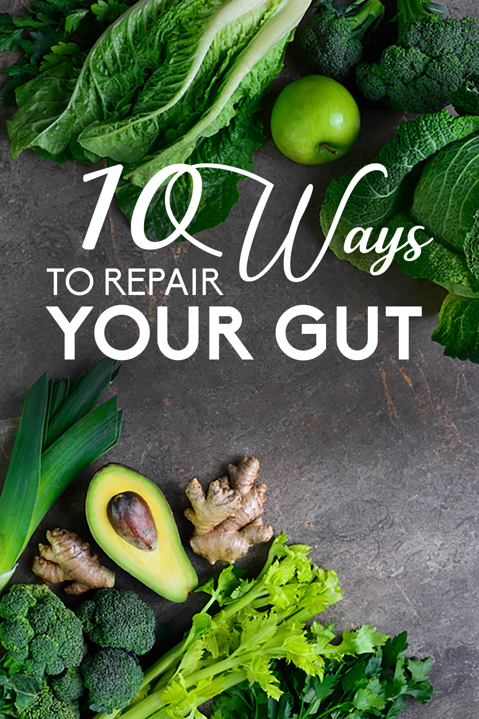
10 WAYS TO REPAIR YOUR GUT
“You are what you eat”…but more accurately you are what you digest and absorb.
Many people, suffering from intestinal diseases continue to live by their daily routine, not even realizing that their seemingly unrelated health issues have their origin in the gut.

What is Leaky gut? (Altered intestinal permeability)
Along the lining of the digestive tract, there lies a very thin layer of cells which together act almost like the toll taker at a toll booth, regulating the passing of various substances from the gut into the blood. When the lining deteriorates, many problems can arise. For example: toxins, large food/protein particles, microbes, and other metabolites enter the bloodstream and cause various diseases along with the inflammation of the gut itself. The body sees these particles that pass through as “invaders”, more scientifically this is called molecular mimicry, and it mounts defenses to get rid of these foreign substances.

Causes
The causes are numerous, including excessive alcohol consumption, prolonged stress, bacterial imbalance, antibiotics, food allergies/intolerances/sensitivities, and gastrointestinal infections.
Treatment
As for a leaky gut, there are multiple treatment options, but the most comprehensive and effective involves the 5 R’s. This is best done under the supervision of a Functional Medicine Provider(with the assistance of a coach)
- Remove
- Replace
- Reinoculate
- Repair
- Rebalance

SO…. What can I do NOW??

Ditch the Gluten
Gluten intolerance is a common issue amongst a good portion of the population, and you might not even recognize the symptoms.
“Gluten increases intestinal permeability, which then allows more gluten to be absorbed into the bloodstream; in sensitive people, HLA presents gluten to the immune system and causes it to attack the intestine. In addition to gluten, tight junction leakage is enhanced by many components commonly used by the food industry, including glucose, salt, emulsifiers….”(https://www.ifm.org/news-insights/ai-rise-autoimmune-disease-linked-intestinal-permeability/)

Some symptoms that can be caused by gluten sensitivity and leaky gut:
- Brain fog
- Fatigue
- Bloating
- Headaches

Consider cutting gluten from your diet for 21 days and see if any of your symptoms improve.

Fermented Foods
Fermented foods such as sauerkraut, tempeh, kefir, and other fermented yogurt or kimchi can help you repair the gut. These foods contain a good source of the bacteria which will counter the effects of”bad” bacteria which may have become overpopulated.

Add these in a little bit at a time, as you might have a bit of GI distress when you are getting used to them. Just 1 oz of kefir or 1 tablespoon of kimchi is a good place to start, then increase as tolerated.

Prebiotics
Although the probiotic bacteria are a good source of essential nutrients and enzymes needed to keep the gastrointestinal tract at an optimum level, there is still more we can do. We take the probiotic but tend to overlook the foods in our diet which will ensure the longevity of these good bacteria in our gut. The prebiotics act as “food” for the probiotics. Some examples are listed here:
- Potatoes/Yams
- Onions
- Apples
- Asparagus

Acidity
Having a bitter or somewhat a slightly acidic diet is essential for keeping the levels of gastric acid in our stomach at ideal levels. The acid in our stomach decreases as we age, and can lead to suboptimal digestion. If you don’t have enough acid in the stomach to start breaking down your food(or don’t chew thoroughly enough), then the rest of your gut has to pick up the slack with the digestion process, and since it’s “not their job”, the small and large intestine are not very good at doing this. The less you effectively break down your food, the less nutrients absorbed, and the less benefit you get from that BAS(big a** salad) you just ate!! These undigested particles can pass through the intestinal barrier if you have leaky gut and our bodies then create an inflammatory response to try to deal with this.

Omega-3
Having an adequate amount of Omega-3 in your diet can also help with leaky gut. Studies show that Omega 3s have an anti-inflammatory effect on the entire body, thus helping calm the inflammation of the gut.
“Omega-3 PUFAs can exert a positive action by reverting the microbiota composition in these diseases, and increase the production of anti-inflammatory compounds, like short-chain fatty acids. In addition, accumulating evidence in animal model studies indicates that the interplay between gut microbiota, omega-3 fatty acids, and immunity helps to maintain the intestinal wall integrity and interacts with host immune cells. “https://www.ncbi.nlm.nih.gov/pmc/articles/PMC5751248/

Some examples of ways to add some Omega 3s are:
- Flaxseed
- Chia seed
- Hemp seed
- Walnuts/Almonds
- Salmon (wild caught preferred over farm raised)

Bone Broth
Another thing you can add to help in the complete healing and repair of the gut is something nourishing and hot at the same time and bone broth serves both purposes quite effectively. Having the bone broth two times a day is considered ideal as it contains an abundant number of vitamins and minerals including collagen and glucosamine. Glucosamine creates connective tissue in our digestive tract that aids in the processing of food and protects our overall immunity, while the amino acids in collagen support intestinal mucosal healing.
These can have a proper “heal & seal mechanism” for the gut in effect and get the job done!

Herbal Tea
Herbal teas can be your best friend as you tackle a variety of health issues.

According to Dr. Will Cole:
“These(herbal teas) are made from a combination of plants, fruits, herbs and spices and are caffeine-free. But what they lack in the caffeine department they make up for with their powerful health benefits. Whatever health problem you are dealing with, chances are there is an herbal tea out there to help your symptoms.” https://drwillcole.com/best-caffeine-free-teas-improve-inflammation-gut-health-fatigue/

Some great options for gut healing herbal teas are:
- Licorice: licorice helps heal damaged gut lining.
- Peppermint: This herb can reduce inflammation
- Slippery elm: This type of elm tree is a known to reduce inflammation in the gut which helps to ease symptoms of IBS and other digestive problems.
- Marshmallow root: Don’t go running for those cereal treats just yet This root repairs damaged gut lining and can help heal leaky gut syndrome. It may help relieve symptoms of constipation, diarrhea, and heartburn as well.

Foods rich in fiber
Studies show a positive relationship between gut health and intake of foods which are high in fiber. These foods rich in fiber not only increase the gut mobility and the number of good bacteria present, but also help with elimination and that in turn decreases our toxic burden.
Fiber is defined as :“dietary material containing substances such as cellulose, lignin, and pectin, that are resistant to the action of digestive enzymes”. Due to its “sticky” nature, fiber takes with it toxins, excess estrogen, and pathogens.
Fiber is found in plant-based foods like whole grains, nuts, legumes, vegetables, and fruits. Be sure to choose gluten free grains as you try to heal your gut.
Some good gluten free choices are:
- Amaranth
- Buckwheat
- Millet
- Steel cut, gluten free oats

Green leafy vegetables
There is a lot of talk about the health benefits of green leafy vegetables, and all that hype is real! These superstars are low in calories, high in phytonutrients, vitamins and fiber. Leafy greens also help to fuel the growth of good gut bacteria which are often lacking(or out of balance) with leaky gut.
Some superstar green veggies that you can consider adding to or increasing in your diet are:
- Kale
- Spinach
- Mustard greens
- Romaine lettuce
- Arugula
- Dandelion greens
- Beet greens
- Dark green leaf lettuce

Aloe Vera
This essential food is vital to combat the inflammation which comes with a leaky gut and promote healing. Aloe vera, has antimicrobial, antitumor, and anti-inflammatory properties and helps to keep the gut healthy and working at its optimum levels.
As with any supplement, I recommend you discuss aloe vera supplementation with your Functional Medicine Provider.

I would love to hear if you use any of these strategies listed above and how they work for you as you embark on this gut healing journey!

.

Disclaimer

The information contained in this document is being provided to you for educational, informational and self-empowerment purposes ONLY. This content is not intended to prevent, diagnose, treat or cure any disease or medical conditions.
I am not a medical doctor, registered dietician, nutritionist or hold any medical license. I make no claims to any specialized medical training nor do I dispense medical advice or prescriptions.
This content is not intended to replace medical advice or guidance from a licensed medical professional. Please consult your doctor or licensed practitioner if you have any questions regarding the suggestions made in this content, are taking any medications or have any pre-existing conditions.
Use this information at your own risk. No results are promised or guaranteed.

For my full Disclaimer, please go to rebeccaarsena.com

